There are 3 tasks each worth 33.3%

1. Turn to page 434 and complete Q18

Print screen your running app below here

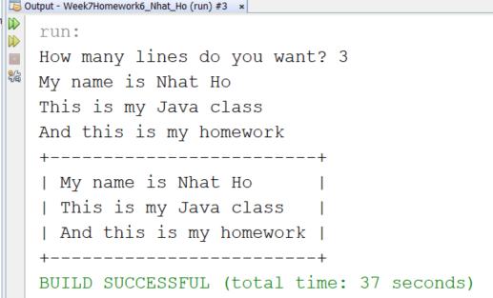

Copy and paste your code below here

package week7homework6_nhat_ho;

import java.util.Scanner;

public class Week7Homework6_Nhat_Ho

{

public static void main(String[] args)

{

Scanner scan = new Scanner(System.in);

int i = 0, lengthMax = 0, numLines;

System.out.print("How many lines do you want? ");

numLines = scan.nextInt();

scan.nextLine();

String[] lines = new String[numLines];

while(i<numLines)

{

lines[i] = scan.nextLine();

if(lengthMax < lines[i].length())

lengthMax = lines[i].length();

i++;

}

topBottomLine(lengthMax);

printContent(lines, numLines, lengthMax);

topBottomLine(lengthMax);

}

public static void topBottomLine (int length)

{

System.out.print("+");

for (int i = 0; i <= length + 1; i++)

System.out.print("-");

System.out.println("+");

}

public static void printContent (String lines[],int numLines, int lengthMax)

{

String line;

int spaces;

//System.out.println(lengthMax);

for(int i = 0; i < numLines; i++)

{

line = "| " + lines[i] ;

System.out.print(line);

spaces = lengthMax - lines[i].length();

while(spaces-- > 0)

System.out.print(" ");

System.out.println(" |");

}

}

}

1. Turn to page 435 and complete Q21

Print screen your running app below here

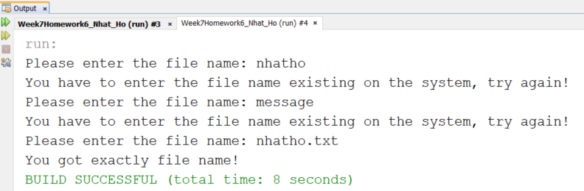

Copy and paste your code below here

package week7homework6_nhat_ho;

import java.io.File;

import java.util.Scanner;

public class question2

{

public static void main(String[] args)

{

String fileName;

Scanner scan = new Scanner(System.in);

do

{

System.out.print("Please enter the file name: ");

fileName = scan.nextLine();

File f = new File(fileName);

if(!f.exists())

{

System.out.println("You have to enter the file name existing on the system, try again!");

continue;

}

System.out.println("You got exactly file name!");

break;

}while(true);

}

}

1. Turn to page 436 and complete Q4

Print screen your running app below here

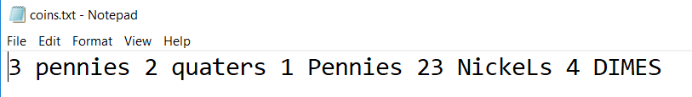

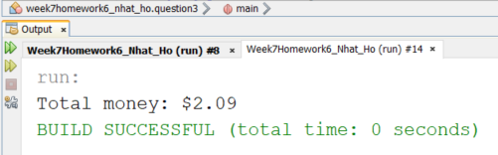

Copy and paste your code below here

package week7homework6_nhat_ho;

import java.io.File;

import java.io.FileNotFoundException;

import java.util.Scanner;

public class question3

{

public static void main(String[] args)

throws FileNotFoundException

{

Scanner scan = new Scanner(new File("coins.txt"));

countCoins(scan);

}

public static void countCoins(Scanner scan)

{

int numCoins;

double sum = 0;

String typeCoins;

while(scan.hasNext())

{

numCoins = scan.nextInt();

typeCoins = scan.next();

switch(typeCoins.toLowerCase())

{

case "pennies":

sum += numCoins * 1;

break;

case "nickels":

sum += numCoins * 5;

break;

case "dimes":

sum += numCoins * 10;

break;

case "quaters":

sum += numCoins * 25;

break;

}

}

sum /= 100;

System.out.println("Total money: $" + sum);

}

}

Submit this document to Week 7 homework